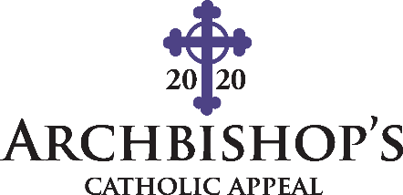

Appeal Social Media Post Templates

How to share this message in your social media accounts

Step 1: Copy the Facebook post option text you desire to share, including the url. Paste this text into your Facebook post.

Step 2: Click publish to post to your parish’s Facebook and/or other social media accounts.
------------------------------------------------------------------------------------------------------------------------------------------
English Templates

Option #1 (COPY THIS) Archbishop's Catholic Appeal introduces new parish emergency fund. Learn more at archden.org/serveothers

Option #2 (COPY THIS) The Archbishop's Catholic Appeal is a lifeline to nearly 40 ministries during COVID-19, but we need you. Learn how you can help at archden.org/serveothers

