Bulletin Announcements

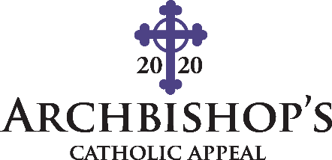
During this pandemic, your neighbors need a helping hand. Extend the mercy and compassion of Jesus Christ by making an online gift to the Archbishop’s Catholic Appeal today; and know that your donation will help those in their time of greatest need. To make an immediate impact on our faith community visit www.archden.org/givetoday or call 303.867.0614.

During these difficult times, people are in desperate need of help and hope. Together, with your support, the Church can continue to carry out the works of Jesus Christ, extend God’s love, and serve those most in need. You can be a pillar of hope by visiting www.archden.org/givetoday or call 303.867.0614 to give to the Archbishop’s Catholic Appeal.

The Archbishop’s Catholic Appeal is a lifeline to ministries during this COVID-19 crisis. Give today to help the most urgent needs in our archdiocese. Gifts to the Appeal are immediately invested in works of religion, education, and charity. Please visit www.archden.org/givetoday or call 303.867.0614.

“Do not neglect to do good and to share what you have; God is pleased by sacrifices of that kind.” (Hebrews 13:16) Your sacrifice will affirm your desire to make Christ known to others. Please give to the Archbishop’s Catholic Appeal. Visit www.archden.org/givetoday or call 303.867.0614.

Consider joining the Archbishop’s Catholic Appeal with a monthly recurring gift which is fast, easy, and secure. Your gift will benefit the ministries throughout this crisis so you can see the impact in action. To join the growing number of monthly recurring donors, please visit www.archden.org/givetoday or call 303.867.0614.

