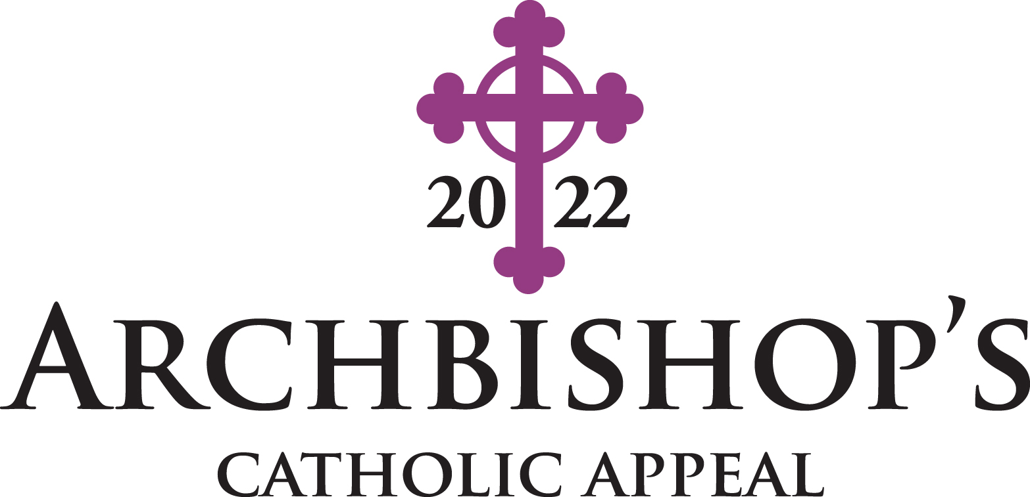

Parish Drive Plan

Appeal Contact Information:
Maria Ramirez, Senior Campaign Manager – maria.ramirez@archden.org
720.476.7466 (English and Spanish inquiries)

If you require additional copies of this manual,
please contact the Appeal Office
or visit the Archbishop’s Catholic Appeal parish portal at:
denverparish.org/aca

Table of Contents

Master Calendar….……………………………………………………………………………....2

Parish Rebates…………………………………………………………………………………...3

Tips for a successful Appeal……………………………………………………………………4

Processing Instructions………………………………………………………………………..5-6

2022 APPEAL
MASTER CALENDAR

Ash Wednesday March 2
Easter Sunday April 17
Major Donor Mailing and General Mailing #1 April 8

Announcement Weekend (Divine Mercy Sunday) April 23-24
(pulpit announcement)

Commitment Weekend April 30- May 1
(video shown)

Follow-Up Weekend May 7-8
(pulpit announcement)

Commitment Weekend and Follow-Up
Weekend “In-Pew” Donation Cards are due
at the Appeal Office May 13

PARISH REBATES

2022 Archbishop’s Catholic Appeal

●The two-tier rebate policy (25% and 50%) will continue in 2022. The guidelines are as follows:

● For Parishes That Exceeded their Goal in 2021: Once the 2022 paid amount exceeds their 2022 goal, 50% of additional funds collected will be returned to the parish.

● For Parishes That Did Not Exceed their Goal in 2021: Once the 2022 paid amount exceeds their 2021 paid amount, 25% of additional funds collected will be returned to the parish. If the 2022 paid amount exceeds their 2022 goal, 50% of additional funds will be rebated to the parish.

● No archdiocesan assessment is made on rebates.

● Rebates are unrestricted.

TIPS FOR A SUCCESFUL APPEAL

Reminders to Pastor
● Read the Appeal pulpit letter at all Masses on Announcement Weekend, April 23-24.

● Show the 2022 Archbishop’s Catholic Appeal video at all Masses on the weekend of April 30 – May 1.

● Send video via Flocknote to your parishioners (see flocknote library.)

● If you do not think it is feasible to show the video at Mass, please call the Appeal Office at 720.476.7466.

● Make a personal endorsement of the Appeal in the pulpit.

● Read the Appeal pulpit letter at all Masses on Follow-Up Weekend, May 7-8.

Reminders to Parish Staff

● Make sure that donation envelopes and brochures are available and will be restocked in the pews after each Mass.

● We created a portal to assist in your promotion efforts at denverparish.org/aca. The resource portal includes:
- Schedule of important dates
- Pulpit letters
- Intercessions
- Bulletin announcements
- Video links
- Logos
- Parish Drive with instructions
- Parish audit forms
● Schedule flocknote message (found on AOD Special Announcement Library.)

● Please follow the “ACA IN-PEW CAMPAIGN 2022 PROCESSING INSTRUCTIONS” in the next section for specific procedures on auditing.

Checks Received – Loose and Envelope
- Checks received do not need to be sorted or tallied.
- Please rubber band/paper clip them together, into 2 batches, if applicable.
Batch 1 – Loose Checks in Offertory
Batch 2 – Envelopes with Checks/Money Orders – please do not separate checks from envelopes or staple.
- Include the batches in the provided postage paid envelope.
- Important if the check is made out to the Parish, please include with the other checks, the Appeal Office can deposit these checks.
Cash Received – Loose and Envelope
Loose Cash in Offertory
- Two unrelated volunteers are needed to tally cash.
- Sort cash by denomination.
- Fill out the enclosed Loose Cash Donations form.
- Deposit Cash into the Parish bank account.
- Write a Parish check for the total amount found on the Loose Cash Donations form and paper clip Parish check to the form.
- Include the form and Parish check in the provided postage paid envelope.
Envelopes with Cash
- Two unrelated volunteers are needed to open and record envelopes with cash.
- Remove the donation card and the cash.
- On the donation card write the amount, “Cash” and the volunteers initials (i.e. $50 Cash AW).
- Sort cash by denomination.
- Fill out the enclosed Envelope Cash Donations form.
- Deposit Cash into the Parish bank account.
- Write a Parish check for the total amount found on the Envelope Cash Donations form and paper clip Parish check to the form.
- Please rubber band/paper clip the empty envelopes/donation cards with the cash amount and initials written on them.
- Include the form, Parish check and empty envelopes in the provided postage paid envelope.

Checklist for Postage Paid Envelope to the Appeal Office
Please include the following items in the provided 10”x13” envelope addressed to the Appeal Office:
- Donor Checks – including those checks made out to the Parish
  - Loose checks
  - Envelopes with checks
- Empty Envelopes– empty envelopes and donation cards that previously contained cash
- Forms – Loose Cash Donations and Envelope Cash Donation forms
  - Make sure you have a copy for your records before enclosing
- Parish Check – signed and made out to Archbishop’s Catholic Appeal
  - Option 1: one check – with two-line items, one for Loose Cash Donations and one for Envelope Cash Donations
OR
  - Option 2: two checks – one for the Loose Cash Donations form and one for the Envelope Cash Donations form

Appeal Thank You Cards and Tax Receipts
The Appeal Office will send Thank You cards to the donors upon receipt.

Hand Deliver Envelope to the Appeal office
If you wish to hand deliver the 10” x 13” envelope, the Appeal Office is located at 1300 S. Steele St. Denver, CO 80210. Please ask for the Donor Relations Team.

DUE DATE
All donations are due to the Appeal Office on May 19, 2022.

Questions
If you have any questions regarding the ACA In-Pew Campaign 2022 Processing Instructions, please contact Donor Relations at (303) 867-0614.

Please do not include any CASH in the envelope to the Appeal Office

